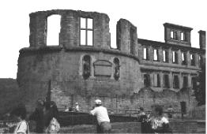
The Heidelberg Peace and Security Council
c/o Mahnwache beim Zeitungsleser
Hauptstrasse/St. Annagasse
69117 Heidelberg
kontakt@antikriegsforum-heidelberg.de

Writ of Summons

Hearing in Matters of the Suspicion of
the Execution or Support
of War Crimes and Crimes Against Humanity

Dear Madam, dear Sir,

On March 20, 2003, collaborating with troops from a few other states the military forces of the United States started an unprovoked war of aggression against Iraq. This war constitutes a blatant violation of the Charter of the United Nations.

According to international law, the mere execution of such a war of aggression is all by itself a war crime and a crime against humanity.

“To initiate a war of aggression,” in the words of the judges at the Nuremberg trial of the Nazi leadership after World War II, “is not only an international crime; it is the supreme international crime differing only from other war crimes in that it contains in itself the accumulated evil of the whole.”

In the war itself, further war crimes were committed, including:

- the massive bombings of civilian targets, especially the destruction of power and
water plants
- the use of prohibited and extremely cruel weapons such as cluster bombs and
ammunition containing depleted uranium
- the destruction of Iraqi radio and TV stations and facilities as well as attacks on
independent journalists
- the starving of the population of whole cities

For war crimes and crimes against humanity, all participants are criminally responsible not only on a national, but also on an international level.

As an affiliate or employee of the armed forces of the United States or one of the coalition states” that took part in the war of aggression against Iraq, you are member of an organization that has committed or supported serious war crimes.

According to a decision of the Heidelberg Peace and Security Council passed on April 10, 2003, in accord with its local jurisdiction, you are herewith summoned to a public evidentiary hearing to testify on and account for your possible complicity in the said crimes.
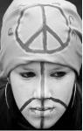
Date/Time of the hearing: April 28, 2003, 6 PM
Location: Hauptstrasse/St. Annagasse

Heidelberg, April 14, 2003. Signed:

